Chapter 19, Solution 8.

To get z₁₁ and z₂₁, consider the circuit below.

j4
I₁ -j2 5 I₂ =0

+
j6 j8
+
V₂
V₁

10 -
-

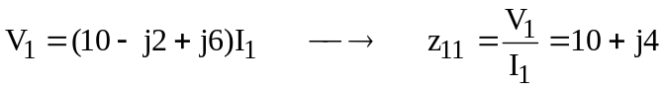

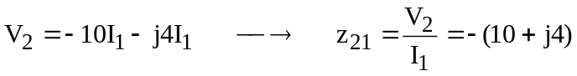

To get z₂₂ and z₁₂, consider the circuit below.

j4
I₁=0 -j2 5 I₂

+
j6 j8
+
V₂
V₁

10 -
-

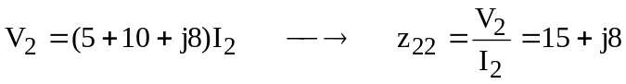

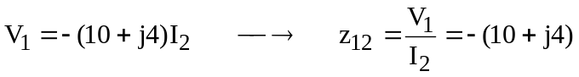

Thus,

